WSN Encoding:

* Environment example:

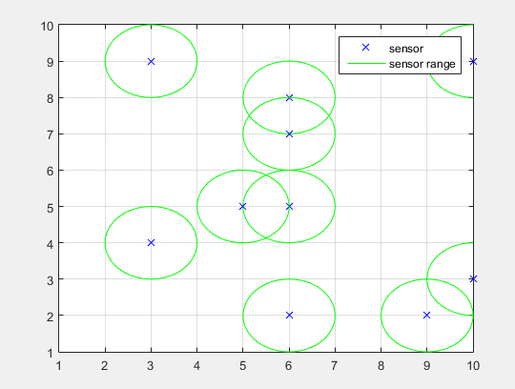

* Env= matrix(Width,height)
* We deal with Env as vector by flatenning it
* Area= Width\*hight
* Env=1:Area
* So this environment is discretete and the coodrdinates are like above (1,1),(1,2) …… etc
* But programally, each point coordinate is represented by single number, for example:

(1,1) 🡪 1

(10,10) 🡪 100 and so on

* Particle position representation:
* For example, If the particle position consists of 2 sensors

Then it is like that

(x1,y1,x2,y2)

* But programmally, we encoded it like that:

(pos1,pos2)

* Because we reduced each point coordinates to single number as we have done for environment
* WSN particles Interaction:
* Each particle position is a vector of sensors positions
* So the particles interacts each other like that:

For i=1:length(particlePos)

newParticleVelocity(i)= ParticleVelocity(i)\*w + rand\*C1\*(localBestPos(i)-ParticlePos(i))+ rand\*C2\*(globalBest(i)-particlePos(i))

newParticlePos=particlePos+newParticleVelocity

end

* so there is no specified arrangement for particles interaction here